LMS ER-1
LIBRARY MANAGEMENT SYSTEM
1. PROBLEM STATEMENTS
● The library management system handled by library staff shows all the available books and their count and also books taken by people, the date on which they took that particular book, return date and due date, and so on.
● It keeps track of the staff as well as the readers with a single point authentication system comprising login Id and password for staff and barcode scanner for students.
Publishers have publisher id name and year of publication

● The staff details include staff id, staff name and designation.
● Staff maintains the book catalog with its ISBN, Book title, price, category (academic, novels, scriptures), edition, author Number.
● Readers are registered with their user_id , user category, email, name, Phone no. , and address.
● Readers can borrow/return books that stamps with issue date and return date issuer’s name, issuer’s id
● Staff also generate reports that has readers id, registration no of report, book no and return/issue info.

ENTITIES:
● PERSON: Readers, staff, publisher

● Event: issuing the book, returning the book,, Authentication, report generation
● Objects: Books
ATTRIBUTES FOR ENTITIES
ENTITY TYPE | ATTRIBUTES TYPE KEYS
Reader | Name  Composite  User_Id  Simple  primary key  Email  Simple  Address  Composite  phone no.  simple
Staff | Name  Composite  Staff_id  simple primary key
Books  Publisher  Authentication  Issuing  /Borrowing  Reports | Author  Composite  ISBN number  Simple  primary key  Title  Simple  Edition,  Simple  Category  Multivalued  Price  Simple  Name  Composite  PublisherId  Simple  primary key  Year of publication  Simple  LoginId  Simple  primary key  Password  Simple  Reserve date  Composite  Due date  Composite  Return date  Composite  Report_id  simple  primary key  Report_name  composite  Report_maker  composite

RELATIONSHIP FOR MY ENTITIES
● A reader can reserve N books but one book can be reserved by only one reader. The relationship 1:N.
● A publisher can publish many books but a book is published by only one publisher. The relationship 1:N.
● Staff keeps track of readers. The relationship is M:N. ● Staff maintains multiple reports. The relationship 1:N. ● Staff maintains multiple Books. The relationship 1:N.
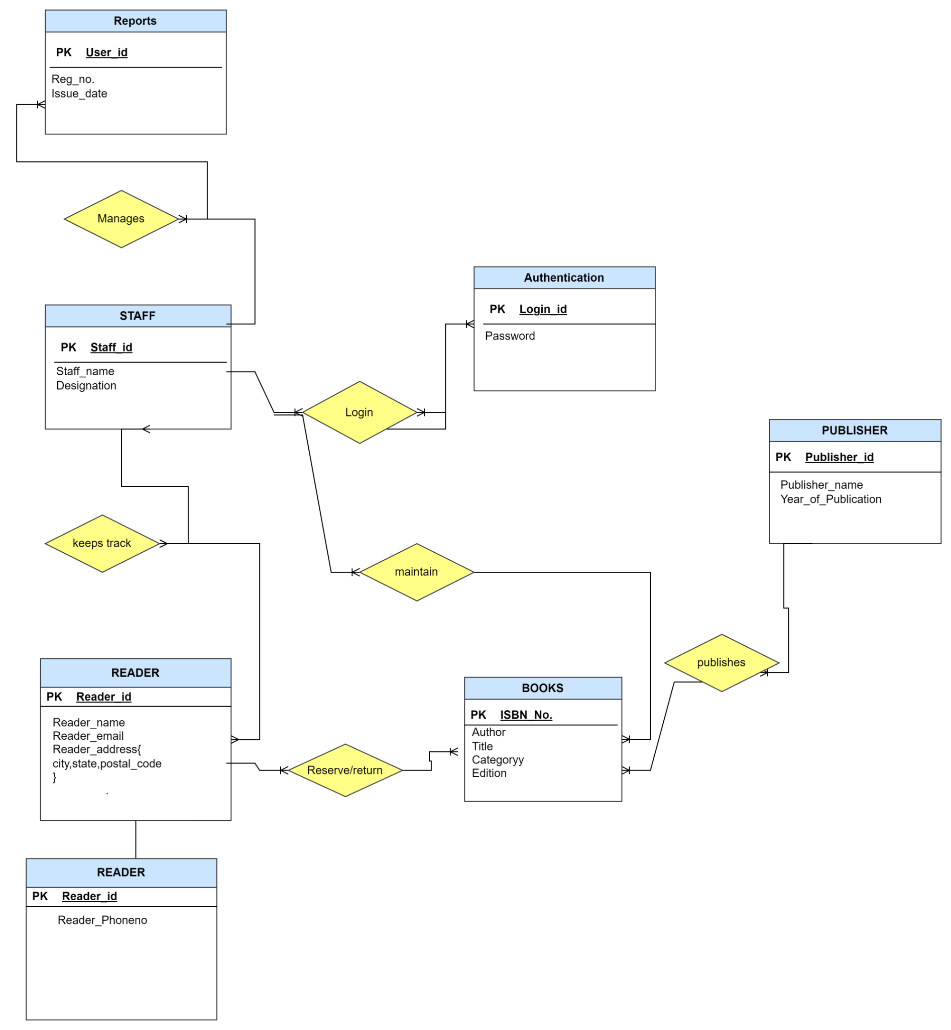
● Authentication system provides login to multiple staffs. The relation is 1:N.

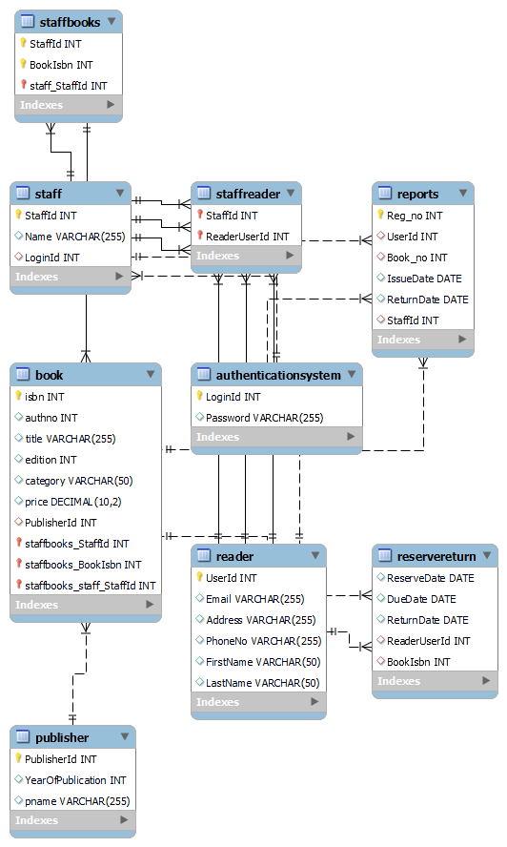
NORMALISATION

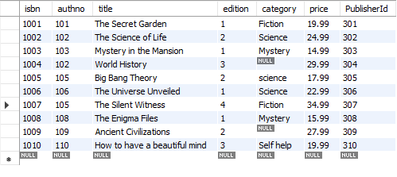

The table selected for normalization is BOOK Table.
This relation is already in ‘1-NF’ form because no multivalued attribute(atomic) is present.
The key for this table is (isbn, publisherid).
The FDs are F= {AG TO BCDEF}
BCDEF may have redundant values so they won’t form the key.
Prime attributes are ->{A,G}
Checking for partial dependencies
A TO B/ A TO C
A TO D/ A TO E
A TO F/ G TO B
G TO C/ G TO D
G TO E/ G TO F

Non-prime attributes are partially dependent of the part of primary key

2-NF decomposition
Steps:
1. {A, G}->Prime, {B, C, D, E, F, }->Non-prime
2. Candidate key is a composite key
3. Non-Prime attribute are fully dependent on the Prime attribute
4. Non-Prime attributes are not partially dependent on the candidate key
A TO B/ A TO C
A TO D/ A TO E
A TO F/ G TO B
G TO C/ G TO D
G TO E/ G TO F
All the above 12 functional dependencies are creating problem because there are non-prime attributes are in partially dependent on the candidate key.
So new relation will be created for each one of them.
Checking for 3-NF
1. It is already in 2-NF
2. There are no Transitive dependencies
So the above relations are in 3-NF

